**Guangdong Modern Dance Company 广东现代舞团 (Est. April 1992 in Guangdong, China)**

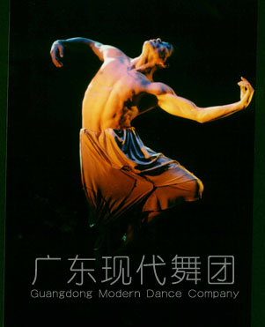

image source: <http://culture.people.com.cn/BIG5/5916014.html>

*Dreaming of Li Bai* (2001)

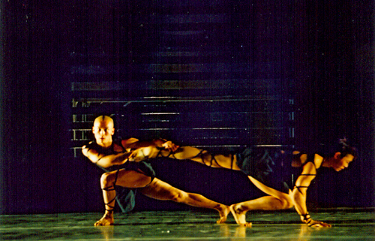

image source: <http://gdart.com/gdwd/gdwdzx/gdwdsc/200605250026.htm>

*Upon Calligraphy* (2005)

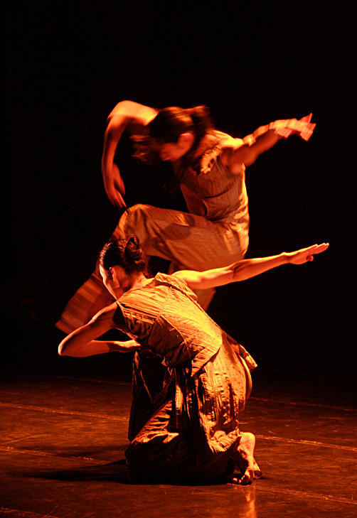

image source: <http://ent.sina.com.cn/j/2009-08-14/00402653069.shtml>

*Rice, Spice, Zen, Colors* (2009)

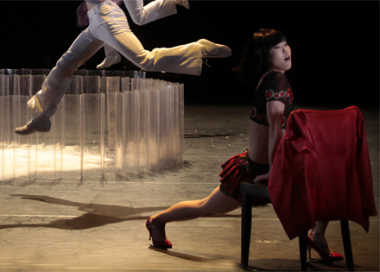

Image source: <http://www.google.com/imgres?hl=zh-CN&client=firefox-a&hs=Awl&sa=X&rls=org.mozilla:en-US:official&tbm=isch&prmd=imvns&tbnid=MMEoeeC1Gc_gwM:&imgrefurl=http://go.eslite.com/Event.aspx%3Fid%3D358&docid=ggcP-T610NJimM&imgurl=http://pic.eslite.com/Upload/MediaEvent/2009/358/128983459822719580.jpg&w=440&h=315&ei=oiwQUIqhLeT40gGvq4H4BA&zoom=1&iact=hc&vpx=449&vpy=460&dur=3183&hovh=190&hovw=265&tx=125&ty=120&sig=107862665764190375784&page=1&tbnh=144&tbnw=190&start=0&ndsp=24&ved=1t:429,r:14,s:0,i:114&biw=1174&bih=813>

**Summary**

The Guangdong Modern Dance Company (GMDC) is China’s first professional modern dance performance group. GMDC was founded in 1992 as the ‘Guangdong Experimental Modern Dance Company’ under the leadership of founding director Yang Meiqi 杨美琦 and artistic director Willy Tsao 曹诚渊, and with approval from the provincial government of Guangdong, China. GMDC received early support from American Dance Festival chairman Charles Reinhart and the Asian Cultural Council. Exchange programs facilitated by these groups in the United States were instrumental to the institution of modern dance in China after the 1980s. GMDC’s past artistic directors include Willy Tsao (1992-1998 and 2004-2007), Yang Meiqi (1998-2000), Gao Chengming 高成明 (2000-2004), and Pun Siu-fai 潘少辉(2007-2012). Together with the modern dance program established by Yang Meiqi at the Guangdong Dance School (joint with the Beijing Dance Academy), GMDC has cultivated the core artistic base for modern dance in China and has helped establish Chinese modern dance on the international stage. Beijing Dance Academy, Beijing Dance LDTX, Hong Kong City Contemporary Dance Company, Jin Xing Dance Theatre of Shanghai, and TAO Body Theatre all draw leading modern dance artists from the early Guangdong school. Each summer, GMDC hosts China’s most important modern dance festival and summer camp, attracting students and teachers from around China and the world.

**Early Development**

Several important developments in Chinese modern dance helped make possible the founding of GMDC in 1992. First, Willy Tsao founded the City Contemporary Dance Company in Hong Kong in 1979, with the goal of promoting modern dance in China. In 1985, Yang Meiqi became principal of the Guangdong Dance School, and in 1986 she received a scholarship from the Asian Cultural Council (ACC) to attend the American Modern Dance Festival (ADF) in Durham, North Carolina. After attending ADF, Yang proposed a four-year modern dance curriculum for the Guangdong Dance School and asked Charles Reinhart to provide teachers from the United States to teach at the program. In 1987, the Experimental Course in Modern Dance was established at Guangdong Dance School, with connections to ADF through the Institutional Linkage Program. Willy Tsao, Sarah Stackhouse, Ruby Shang, Douglas Nielson, and Lynda Davis were among the early teachers in the program. In 1988, Jin Xing 金星 was selected from the first class of students to study in the United States, and Wang Mei 王玫, also in first group of students, created the work *Tides*. In 1988-90, the Guangdong Dance School group performed in Beijing, generating attention and acclaim among the Chinese dance community. Works included *City Romance* by Willy Tsaoand *Basket and Bamboo,* a collective creation under direction of Lynda Davis. In 1990, students in the Guangdong course Qin Liming 秦立明 and Qiao Yang 乔杨 won the gold medal in pas de deux at the Fourth Paris International Modern Dance Competition, performing Willy Tsao’s *Passing Voice* and *Impression of Taiji*. In 1991, the Guangdong group was invited to perform at the American Dance Festival.

**Later Development**

After its official founding in 1992, the GMDC became the most important modern dance company in Mainland China. The Company continued to cultivate star performers and choreographers who gained recognition for Chinese modern dance on the international stage. In 1994 company member Xing Liang 邢亮 won the gold medal in male modern solo at the 6th Paris International Dance Competition. In 1996 company member Sang Jijia 桑吉加 won the gold medal in male modern solo at the 6th Paris International Dance Competition. In 2000, Liu Qi’s 刘琦 work *Pagoda* won Grand Prize in the Moscow International Arts Competition. GMDC performed at the American Dance Festival for the second time in 1997, and in 2000 GMDC former member Shen Wei 沈伟 established his own critically acclaimed independent modern dance company Shen Wei Dance Arts in New York City. In 2004, the Guangdong Modern Dance Festival was established, and it became the most important modern dance festival in China. After 2004, China’s cultural industry structural reforms terminated full state subvention and government administration for GMDC. GMDC became a joint venture between Xinghai Performing Arts Development Co., Ltd. of Guangdong, and the City Contemporary Dance Company of Hong Kong.

Emily E Wilcox

**List of Works**

*Insomnia* 不眠夜 (1994) by Shen Wei

*Old Stories* 旧故事 (1994) by Gao Chengming

*Pagoda* 萋萋长亭 (1996) by Liu Qi

*Fight Under the Table* 暗战 (2001) by Liu Qi

*Dreaming of Li Bai* 梦白 (2001) by Gao Chengming

*Upon Calligraphy* 临池 (2005) by Liu Qi

*Forward-For-Forward* 前进前进进 by Liu Qi

*Blue Picasso* 蓝色毕加索 (2007) by Pun Siu-fai

*Merry-Go-Round* 旋转木马 (2008) by Pun Siu-fai

*Thousand Faces of Grimm* 千面格林 (2008) by Pun Siu-fai

*Rice, Spice, Zen, Colors* 米·辣·禅·色 (2009) by Pun Siu-fai

**Website**

[www.gdmdc.com](http://www.gdmdc.com)

**References and Further Reading:**

English:

Ou, Jian-ping (1995) “From ‘Beasts’ to ‘Flowers’: Modern Dance in China.” In Ruth Solomon and John Solomon, ed. *East Meets West in Dance*, Switzerland: Harwood Academic Publishers. pp. 29-35.

(This is an authoritative account of the development of modern dance in China by an esteemed Chinese dance studies scholar with expertise in Western modern dance. Ou contextualizes GMDC in the political and cultural environment of modern dance development in China and offers an explanation of why modern dance developed later in China than in other parts of the world. This is an excellent resource for undergraduate courses in dance history. English.)

Reinhart, Stephanie (1995) “The American Dance Festival’s International Projects: Invention and Implementation, I.” In Ruth Solomon and John Solomon, ed. *East Meets West in Dance*, Switzerland: Harwood Academic Publishers. pp. 7-15.

(Reinhart provides a firsthand account of ADF’s international projects, and discusses the early collaboration with Yang Meiqi that led to founding of GMDC. The article also offers a perspective from the point of view of those who participated in the project, including perspectives on issues of funding, government policy, and personal interactions between members of different groups involved. This is an excellent resource for undergraduate courses in dance history. English.)

Yang Mei-qi 杨美琦 (1995) “Bringing Modern Dance to China.” In Ruth Solomon and John Solomon, ed. *East Meets West in Dance*, Switzerland: Harwood Academic Publishers. pp. 37-49.

(This is a firsthand account of Yang Meiqi’s experiences founding GMDC, and discusses the collaboration with ADF, responses from Chinese dance community, and contributions of the initial group of American dance instructors sent to China. This is an excellent resource for undergraduate courses in dance history. Some images. English.)

Chinese:

王克芬 （1999）“广东试验现代舞团的诞生和北京舞蹈学院现代舞大专班的建立.” 中国近现代当代舞蹈发展史1840-1996. 人民音乐出版社.

(This is an authoritative history of institutionalization of modern dance education in China through the founding of GMDC and the Beijing Dance Academy Modern Dance Professional Program. It contains a brief description of major works, including year, prizes awarded, and choreographers’ names. It is part of a longer history of dance in China from 1840 to 1996. This is an excellent resource for scholars of Chinese dance history. Chinese.)

Wilcox, Emily (魏美玲) (2012) “中国的边缘，美国的中心：陶身体剧场在美国舞蹈节” 舞蹈评论.1: 59-67.

(Wilcox provides an overview of developments in Chinese modern dance since the 1990s, including an overview of ongoing relationships between Chinese modern dance and ADF and career developments of generation of dancers trained in early GMDC. The work focuses on independent, young, modern dance companies and questions of independent versus state-sponsored modern dance in China. Chinese.)